JWB-001_README.PDF

Please refer to fabrication drawing for all specifications and fabrication details.

Quantity: 10

Delivery: Standard

Shipping address:

Jewelbots

c/o Techstars

1407 Broadway, 24th Floor

New York, NY 10018

Design contacts:

Sangeet Dandona

Mobile: (909) 282-2819

Scott Davison

Mobile: (215) 316-2509

Part Number-----------------------: JWB-001

Revision--------------------------: 3.5

Board size------------------------: 0.94488" x 0.94488"

Board Thickness-------------------: 0.036"

Board type------------------------: FOUR LAYER

P.C.B material--------------------: 370HR

Finished Copper-------------------: 1 oz

Finish----------------------------: ENIG

Solder Mask on Bare Copper--------: Yes

Mask type-------------------------: LPI

Mask color------------------------: GREEN

Silk screen color-----------------: WHITE

Surface mount---------------------: Yes

Smallest trace size---------------: 0.003"

Smallest clearance between traces-: 0.003"

Layer Stackup:

|  |  |  |  |  |  |
| --- | --- | --- | --- | --- | --- |
| Layer Name | Type | Material | Thickness (mil) | Dielectric Material | Dielectric Constant |
| Top Overlay | Overlay |  |  |  |  |
| Top Solder | Solder Mask/Coverlay | SurfaceMaterial | 0.4 | Solder Resist | 3.5 |
| Top | Signal | Copper | 1.4 |  |  |
| Core 1 | Dielectric | Prepreg | 6 | 370HR | 4.02 |
| Layer 2 | Signal | Copper | 0.7 |  |  |
| Core 2 | Dielectric | Core | 19 | 370HR | 4.02 |
| Layer 3 | Signal | Copper | 0.7 |  |  |
| Core 3 | Dielectric | Prepreg | 6 | 370HR | 4.02 |
| Bottom | Signal | Copper | 1.4 |  |  |
| Bottom Solder | Solder Mask/Coverlay | SurfaceMaterial | 0.4 | Solder Resist | 3.5 |
| Bottom Overlay | Overlay |  |  |  |  |

Request Impedance Control on the following nets:

Differntial Nets:

ANT1 (Val: 100ohms)

Coord: (124, 244.252) in mil

ANT2 (Val: 100ohms)

Coord: (124, 228.504) in mil

Zo_diff = 50ohms

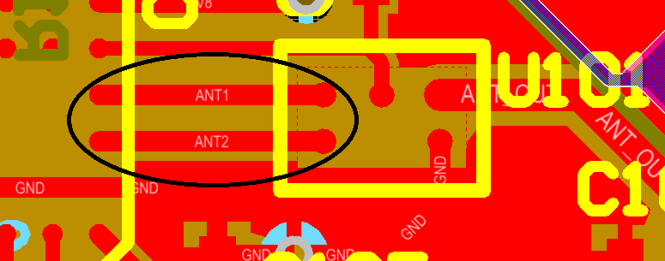

Fig. 1: Diff-pair route

Single Nets:

ANT_OUT (Val: 50ohms)

Coord: (266, 227) in mil

ANT_MATCH (Val: 50ohms)

Coord: (388, 157) in mil

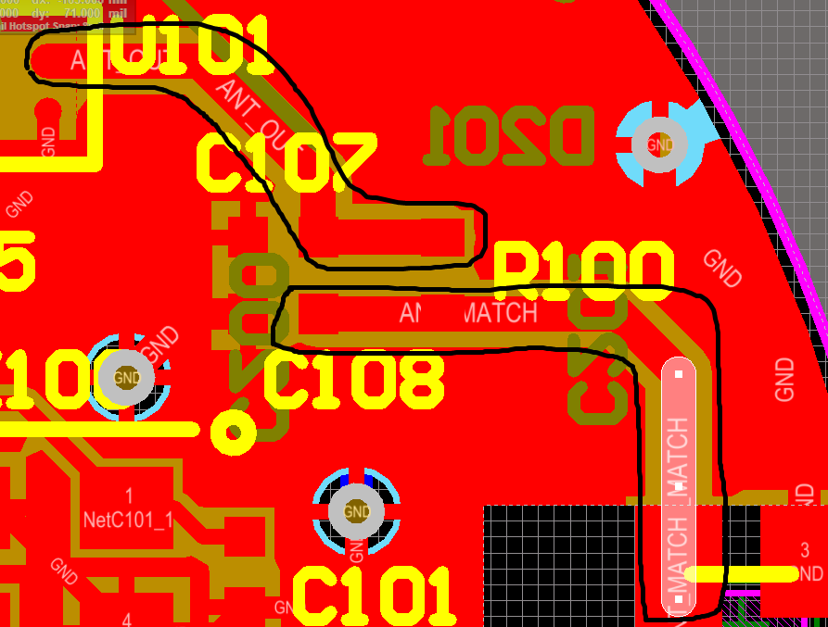

Fig. 2: Single 50ohm traces